Robin Bakker

robinbakker@powerspex.nl

Manual

Explaining the purpose and use cases of the Report Generator.

manual

Report Generator



# Versions

|  |  |  |  |
| --- | --- | --- | --- |
| **Version** | **Date** | **Author** | **Changes** |
| 1 | 28-08-2020 | Robin Bakker | initial |
| 1.1 | 04-09-2020 | Robin Bakker | 1. Important changes to prerequisites. Specific version for ghostscript required. 2. Update ‘Pdf Page settings’ with remove page. |
|  |  |  |  |

# Introduction

This document will is supposed for the users of the Report Generator tool. The document will inform the user on how to use the report generator tool and how to install the tool. All features will be explained to the user.

Inhoud

Versions 1

Introduction 1

1. Purpose 3

2. Installation 3

2.1 Prerequisites 3

2.2 Installation process 3

2.3 Removal process 5

3. Starting tool for the first time 5

3.2 Starting 6

3.2.1 Creating a new configuration 6

3.2.2 Removing a configuration 6

3.3. Setting up the PLC connection 7

4. Configuration editor 8

4.1 PLC Triggers 9

4.2. PDF Elements 11

4.2.1 Global element settings 11

4.2.2 Textblock element 13

4.2.3 Image element 14

4.2.4 TextBox (PLC Binding) 14

4.2.5 Graph element 15

4.2.6 Rectangle element 18

4.2.7 Element actions 18

# Purpose

The report generator is a tool designed to create a dynamic PDF layout where the user can add elements into a PDF page. The PDF’s are split up into configurations, each configuration is a separate PDF. Configurations can be for example ‘Unit1’, ‘Unit2’ or ‘Tunnel 1’, ‘Tunnel 2’. These configurations allow for to make PDF’s for different units.

The report generator uses triggers that communicate with the PLC. For example; “CREATE_PDF” trigger. Once this trigger is set to ‘1’ the report generator will generate a report based on the elements that the user has added.

Certain elements can retrieve a value from the PLC on the ‘CREATE_PDF’ trigger. This makes the PDF dynamic as any value can be retrieved from the PLC.

# Installation

For this project a Github repository has been created, the Github repository is used for tracking versions and changes. For the developer it’s easy to keep track of the changes and rollback when something goes wrong. For the user it’s a central place where the *latest* version of the tool is located.

<https://github.com/powerspex/ReportGenerator/releases>

The above link contains all releases, from the latest release to the oldest release.

## 2.1 Prerequisites

**Ghostscript**  
In order to install the Report Generator we need to have Ghostscript **x32** for Windows installed. This library is used to convert the PDF into readable images. Important to note that only the 32 bit is needed. If you have the 64 bit version installed, uninstall it and install the 32 bit version.

***Important:*** Due to updates to the ghostscript native library we need a specific version of ghostscript. The download page invites you to download 9.52 (as of 04-09-2020). We need version 9.26 . This version enables in-memory PDF conversion which increases performance.

https://www.npackd.org/p/com.ghostscript.Ghostscript/9.26

## 2.2 Installation process

**Step 1**: Once you have installed Ghostscript x32 (v9.26) and the latest release from the Github page the installation is fairly simple. You can run the installer and install the report generator under:

*“C:/Program Files (x86)/Powerspex B.V/Report Generator”*

When you install all other tools under this path all will be very organised and will be in one place.

**Step 2**: When the tool has been installed go to the installation path (*“C:/Program Files (x86)/Powerspex B.V/Report Generator”)* and right-click the PDFGenerator.exe and select ‘Properties’. Then select ‘Compatibility’ and make sure to check the ‘Run this program as an administrator’ checkbox.

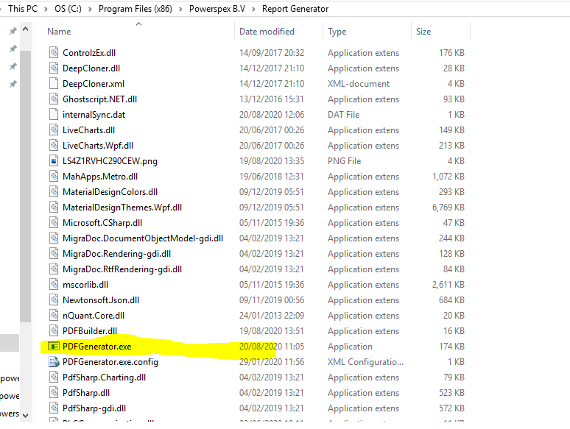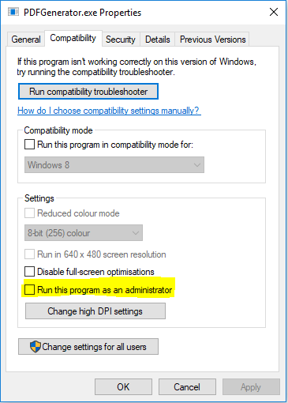

Figure 1 PDFGenerator.exe

**Step 3:** You’re all set now. You can create a shortcut on the desktop for easy access by right-clicking PDFGenerator.exe and select ‘Create shortcut’.

## Removal process

When a new version is released and you need to install the newest release the installer will not remove the previous version. This is *currently* up to the user. Simply go to the ‘Apps and Features’ tab in Windows and search for ‘Report’ or “Report Generator” and click the ‘Uninstall’ button. Once that’s done, you can select the newest version.

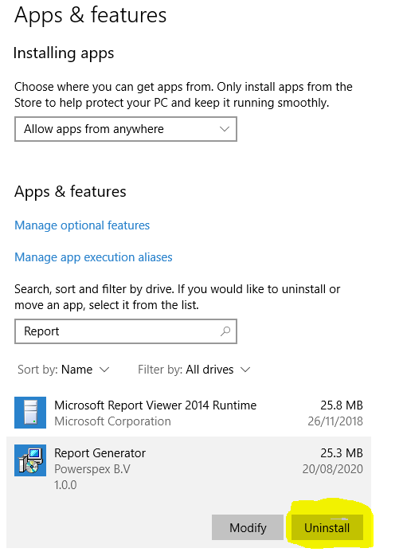

# Starting tool for the first time

When you have installed the tool properly you can run the PDFGenerator.exe file (either from the installation directory or the shortcut you’ve created on the desktop). When you have opened the tool you will see this screen:

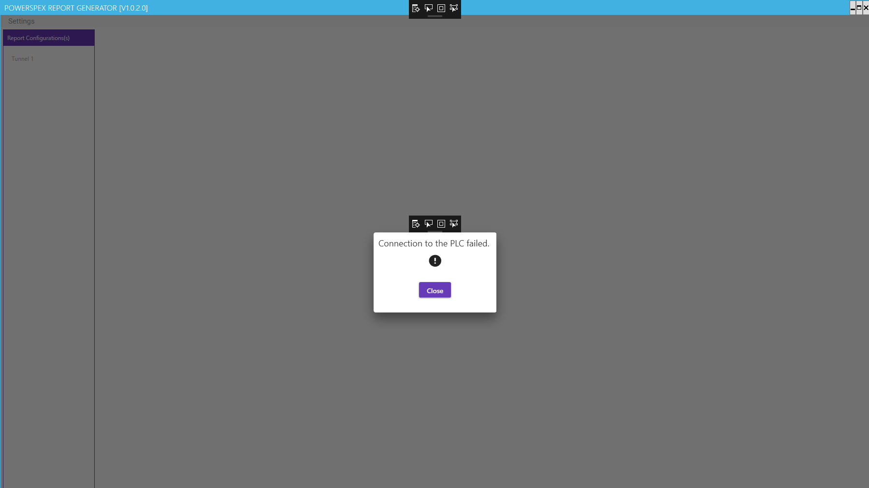

Figure 2 First time opening screen’

This screen is simply to inform you that the tool is currently not connected to the PLC. Don’t worry, it’s fine. You can simply close the dialog and start exploring.

When you look at the header of the application you can see the current version of the tool. In this case it’s V1.0.2.0. When you are not sure whether you have the most up to date version installed, simply compare this to the latest release on Github.

## 3.2 Starting

When you’ve closed the first dialog you have a blank screen. There’s two things you can do at this time, you can create a configuration or you can setup the PLC connection when you know the IP Address already.

***Important:*** it is not mandatory to have a PLC connection in order to setup a configuration. The PLC connection is only needed to generate the PDF’s from the PLC.

### 3.2.1 Creating a new configuration

The left groupbox contains all configurations. I myself already have one configuration(Tunnel) setup. To create a new tunnel right-click and select ‘Add’ all other options will be explained later.

You will get a prompt dialog where you can type in the name of the configuraion, click ‘Save and exit’ and the configuration is created. (But not saved on the disk yet). Renaming a configuration is currently not supported, so choose wise for now.

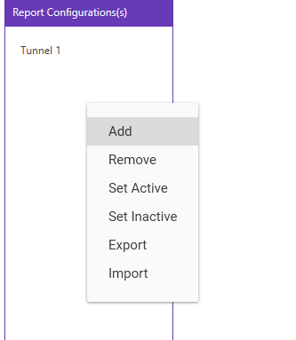

Figure 3 Adding a configuration

### 3.2.2 Removing a configuration

In order to remove a configuration right-click a configuration (Figure 3) select the ‘Remove’ option and the configuration will be removed.

## 3.3. Setting up the PLC connection

At the top left side of the application you can select ‘Settings’ and select the ‘PLC Connection’ button.

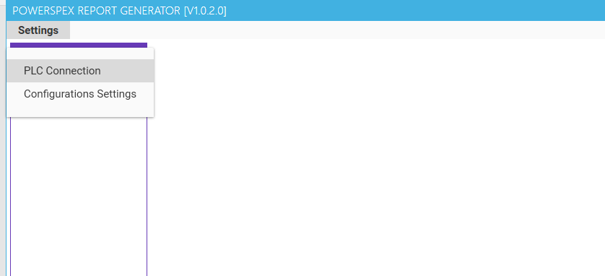

Figure 4 Setup PLC connection

After selecting the ‘PLC Connection’ button you will see the connection dialog.

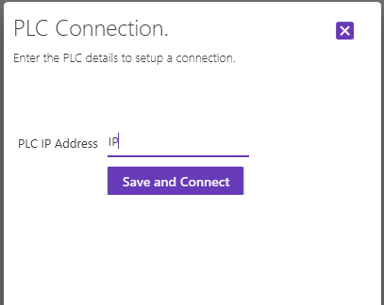

Figure 5 PLC Connection dialog

Simply fill in the PLC IP Address and click ‘Save and Connect’. You will see a message whether the connection succeeded or failed. If the connection is failed, check the connection to the PLC with ping and allow all access to the PLC.

Once you’ve correctly setup the connection to the PLC the IP Address will be stored and when you re-open the application you will see that the application is connected to the PLC. When you re-install the application you need to set it up again.

# Configuration editor

When you have selected a configuration from the listbox when you start up the application you will see the Configuration editor at the right side.

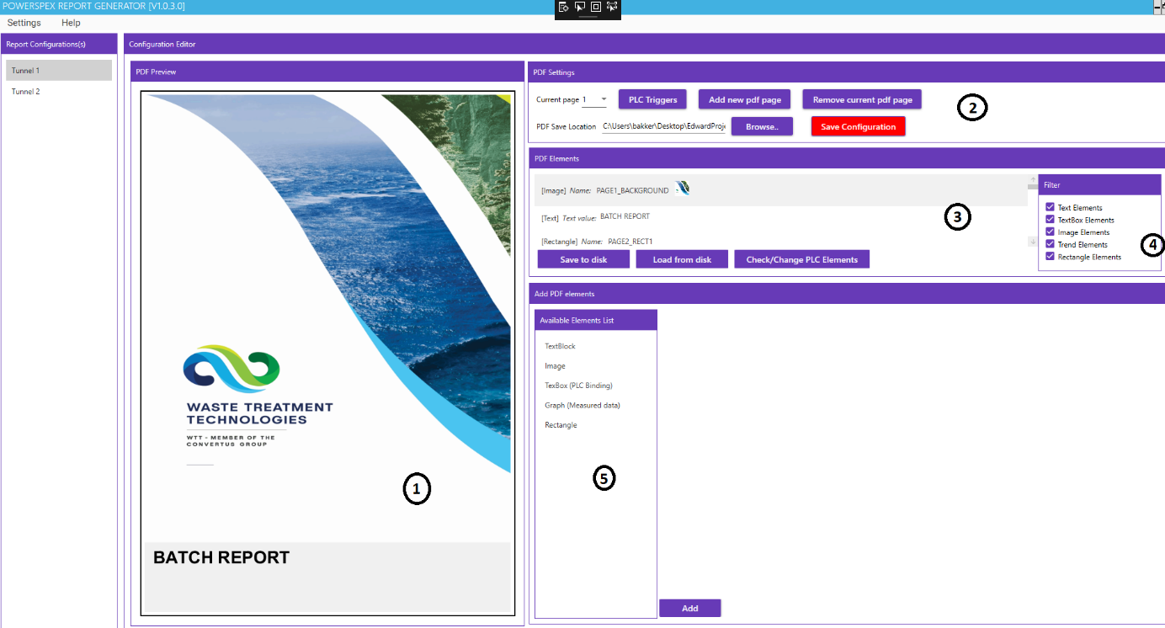

Figure 6 Configuration editor

Above is the Configuration editor. The configuration editor contains all necessary features in order to create PDF for the desired process.

Below all numbers will be explained.

**1:** This is the PDF Preview. When you have added elements to the PDF you will see a preview, this is to show the user what the final PDF will look like approximately. The resolution of the preview might be slightly off, so all elements that have been placed on the PDF will look a little bit better on the final PDF.

**2:** Here are the PDF settings located. Here are a few buttons located in which we will go into detail later. But important to notice is the ‘*Current Page*’. The preview shown in (**1**) is the preview of the current page. When you select another page the preview will be updated.

‘*Add new PDF page*’ will create a new PDF page. You can currently not remove PDF pages.

‘Remove current PDF Page’ will remove the current PDF page. All elements on that page will be removed.

Also important is the ‘*PDF Save Location’*, this is the path to the location where the final PDF’s will be stored. So here you can find the PDF’s with process data.

‘*Save Configuration’* will save the current configuration. Do this frequently to avoid losing important data!

**3.** This is the list of all elements in the PDF. When you right-click on an element you can select whether to Edit or Delete them. Some elements currently do not support editing, such as trend objects.

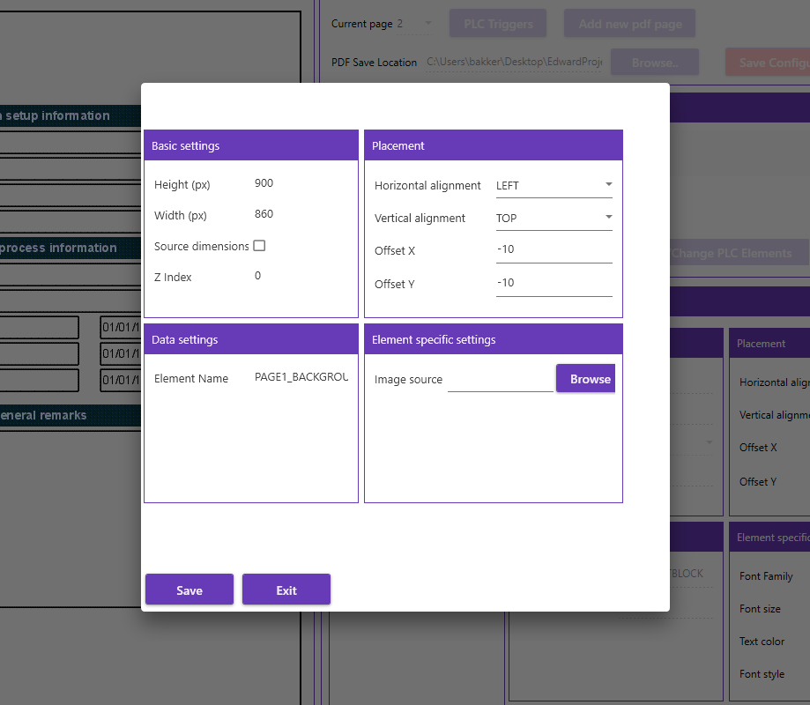

Figure 7 Edit element dialog

Above is the dialog to edit an element from the ‘PDF Elements List’.

Under the list of elements you will find ‘Save to Disk’, ‘Load from Disk’, ‘Check/Change PLC Elements’.

**4:** Here you can select a filter. When you deselect a checkbox will those elements not be shown in the list. This makes searching for certain elements easier.

**5:** This is the element list. When you select an element in this list an editor for the element will be shown to configure the element.

## 4.1 PLC Triggers

The ‘PLC triggers’ button in the ‘PDF Settings’ groupbox will show you a dialog that contains rules for creating a pdf, maybe in the future more.

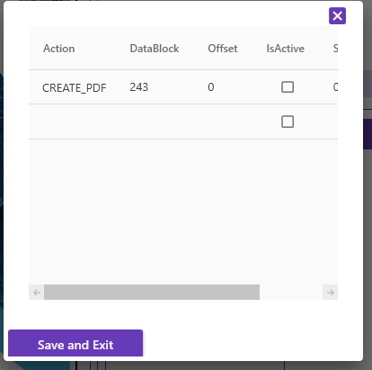

Figure 8 Triggers dialog

The ‘Action’ is the action to perform when the trigger has been set to ‘1’ in the PLC. The Datablock is the DB to look for in the PLC and the offset is the offset in the datablock. The ‘IsActive’ column is not needed as it is only used internally, this will be removed in the future. To the right (scroll to right) is the ‘SecondsTimeout’ column. This is the timeout in seconds when the trigger will evaluate the value in the PLC, when you fill in 5 it will look in Datablock 243, offset 0 each 5 seconds.

**Important:** the trigger will look for an integer, not a Boolean. So make sure that the datablock and offset contain an integer number!

## 4.2. PDF Elements

In this section the PDF elements will be explained in detail.

### 4.2.1 Global element settings

Global element settings are used for every element. The same rules count for every element. Below the basic settings and placement settings will be explained.

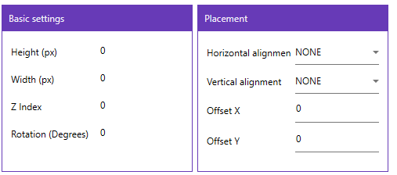

Figure 9 Global element settings

#### 4.2.1.1 Basic settings

The basic settings are available for every element. The height and width are the dimensions of the element. The Z-Index is an important number as this is the number that indicates whether an element is on top or on bottom of another element.

When you for example create a rectangle element and want to place a textblock on top of the rectangle you need to have a higher Z-Index on the textblock than on the rectangle. For example, 0 for the rectangle and 1 for the textblock. When adding more elements on top of each other you can set a higher Z-Index. See the image below for a visual representation.

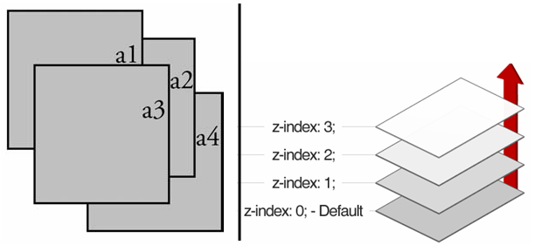

Figure 10 Z-Index example

Rotation is the amount of degrees that the element will be rotated. This is currently a little bit hard with positioning.

#### 4.2.1.2 Placement

Placement contains the settings for the element positioning. The horizontal alignment have 4 options: ‘None’, ‘Center, ‘Left’, ‘Right’. See the image below to see how the element will be positioned.

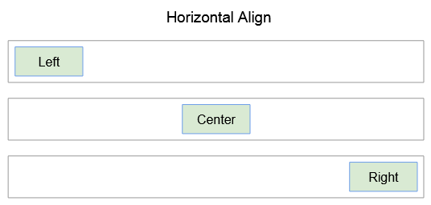

Figure 11 Horizontal alignment example

Vertical alignment is how the element will be positioned vertically. ‘Top’, ‘Bottom’, ‘Center’. You can combine horizontal and vertical alignment.

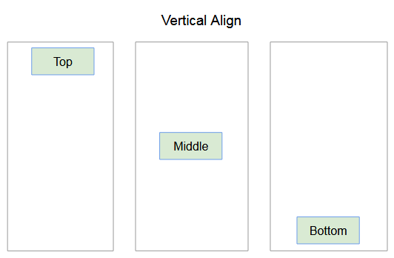

Figure 12 Vertical alignment example

Offset X, and Y are used to create a pixel wise offset. This can also be combined with horizontal and vertical alignment. The picture below shows the x and y offset.

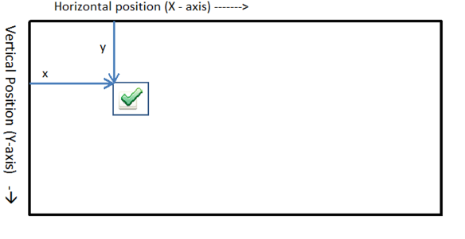

Figure 13 X and Y offset example

#### 4.2.1.3 Element name

The element name is the identifier for the element. The element name is used to identify each element in the PDF. Do not change this element name, and important advice: do not use ‘Element1’, ‘Element2’ etc. Choose a proper name so you can always identify what element you are referencing. When you choose for example ‘Page1_Section1_BatchName’ you can easily identify what page, what section and what the element is. In this case an textblock element on page 1 in section 1. This keeps the configuration a lot more readable.

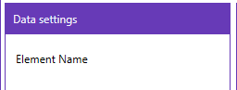

Figure 14 Element name in data settings

### 4.2.2 Textblock element

The TextBlock element is the most simple element, it’s just text.

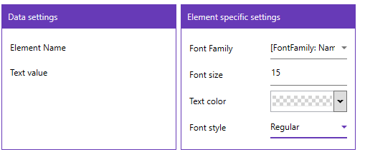

Figure 15 Textblock settings

Make sure to use a proper ElementName, below you can set the text. In the ‘Element Specific Settings’ you can set the FontFamily, FontSize, TextColor (default=Black but shows as transparent!) and the FontStyle (Default=Regular).

### 4.2.3 Image element

An image element is simply an image that you can place on a page. This can also be for the background image per example. This can be used with the z-index with other elements when they need to be placed on top of an image.

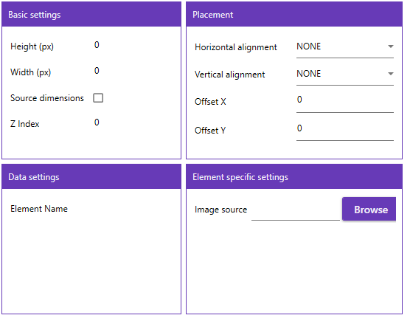

Figure 16 image element settings

The basic settings are a little bit different for an image. You can use the ‘Source Dimensions’ when you select an image in the ‘Element specific settings’ the dimensions of the original picture will be used. This might be very good, but most likely this won’t be used as the source dimensions are normally larger than needed.

### 4.2.4 TextBox (PLC Binding)

The TextBox is one of the most important elements. The TextBox value will be retrieved from the PLC when the trigger is triggered (4.1 PLC Triggers) .

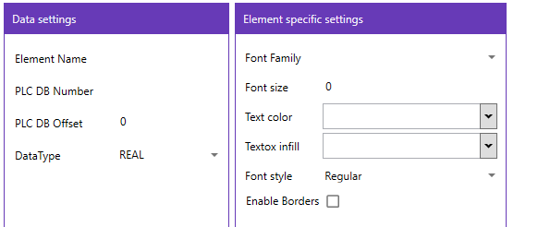

Figure 17 TextBox settings

The ‘Data Settings’ of the TextBox element needs to be filled in correctly. The DB Number, offset and datatype need to be correct. When this is filled in incorrectly an error message will popup when the CREATE_PDF trigger is triggered. The ‘Element Specific Settings’ are nearly the same as for the TextBlock but here are also two additional settings, textbox infill and enable borders.

The TextBox infill will color the inside of the textbox to a certain color. The enable borders will enable the outer borders of the textbox or not. When you disable the borders it will essentially be an textblock, but then with PLC binding.

### 4.2.5 Graph element

The graph element is one of the most complicated elements. The graph element is capable of taking measurements in the tunnel/unit and put them into an graph that you configure. To properly use the graph we also need to take a look at the ‘PsxDataLogger’ tool.

The PsxDataLogger is an external tool that is only used to log data from the PLC. An separate manual will be written for this tool. But in short, the PsxDataLogger will create a file on the disk (.json file) and will log to that file each x seconds that you configure in that tool. These files are selected in the graph settings and will be plotted in the graph.

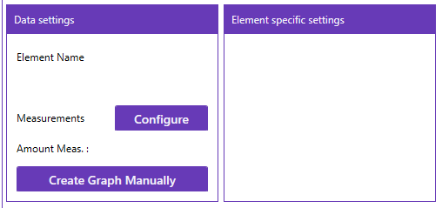

Figure 18 Graph element settings

#### 4.2.5.1 Selecting measurements

The first step is to of course give the graph a proper name. Next up, you select the measurements that you want to plot into the graph. Select the ‘Configure’ button next to ‘Measurements’.

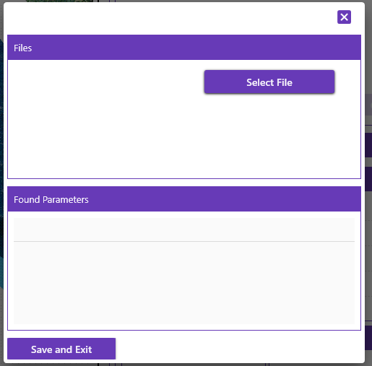

Figure 19 Select measurement files dialog

When you select the ‘Select File’ button an dialog will appear where you can select .Json Files. Now, select the measurement files created by the ‘PsxDataLogger’ tool. You can select more than one, but you need to open the ‘Select File’ dialog twice, or more. I’ve select two measurement files.

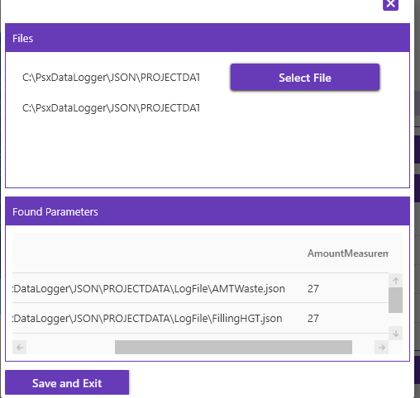

Figure 20 Example selected measurements

As you can see, the name (not shown in picture), path and the amount of current measurements are shown in the data grid. Normally, you can have an zero amount of measurements. When the ‘PsxDataLogger’ starts logging and after that the ‘Create_Pdf’ trigger is triggered all measurements will be retrieved from the file (that you’ve selected in Figure 20!) and will be put into the graph.

When you have selected the measurement files you can click ‘Save and Exit’ to save the measurements.

#### 4.2.5.2 Configuring the graph axis’s with measurements.

When the measurements are added you can click on ‘Create graph manually’ to manually create the graph with the axis’s.

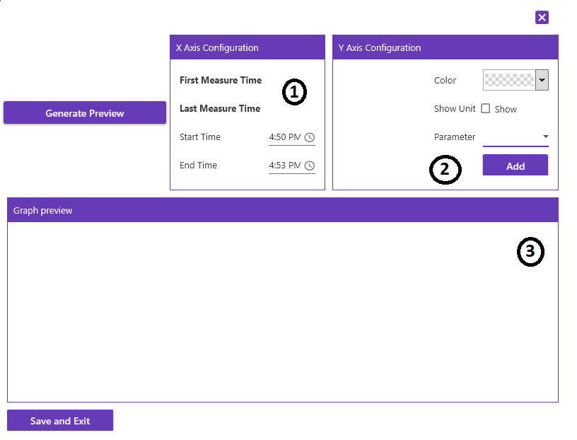

Figure 21 Create graph manually dialog

**1:** This is the X Axis configuration. Normally you do not have to edit each of these parameters. They are automatically calculated based on the first measurement. If there are no measurements yet, but there are when the trigger ‘Create_PDF’ is triggered it will set the begin to the first measurement and the end to the last measurement.

**2:** This is the Y Axis configuration. This does need to be configured, in the ‘Parameter’ combobox you need to select the measurement that you want to add into the graph. You can give that line a color and select whether to show the unit. When you press ‘Add’ it will be added to the graph. Currently removing a Y Axis is not supported so make sure that it is to your liking. You can however close the dialog and select ‘Create graph manually’ again to re-do it.

**3:** This is the preview of the graph. When you’ve added all Y Axis’s you can select ‘Generate Preview’ and see a preview for yourself.

When you are done, you can select ‘Save and Exit’ and afterwards ‘Add’ then the preview will be added to the current PDF page.

**Tip:** to have the graph in landscape mode apply these parameters to the settings:

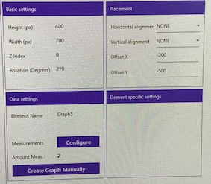

Figure 22 Settings for rotated landscape graph

### 4.2.6 Rectangle element

The last element is the Rectangle element. This will simply draw a rectangle at your desired position.

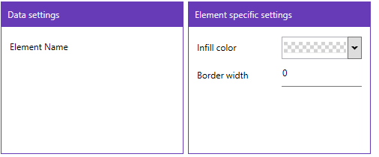

Figure 23 Rectangle settings

You can set the ‘infill color’ of the graph and the border width. You can play with these values to your liking.

### 4.2.7 Element actions

As shown in Figure 6 , number **2** you can:

1. Save elements
2. Load elements
3. Change DB Numbers (Only for textbox elements)

#### 4.2.7.1 Saving elements

All elements can be saved to a single folder. When you click the ‘Save to Disk’ button, all elements will be saved into that folder. The ‘ElementName’ will be the file name.

#### 4.2.7.2 Loading elements

Elements can be loaded from a single folder. When you click the ‘Load from Disk’ button, the elements in that folder will be loaded into the current selected configuration. When there are duplicate ‘ElementName’ for an element it will be skipped as the application does not allow two elements with the same ‘ElementName’.

#### 4.2.7.3 Change DB Numbers

When you click the ‘Check/Change PLC Elements’ button a dialog with a datagrid will popup. All elements with PLC settings will be in this datagrid. Currently, only textboxes will be in here. Each row is one element. This dialog is created to change the DB number, Offset and DataType more easily for elements.

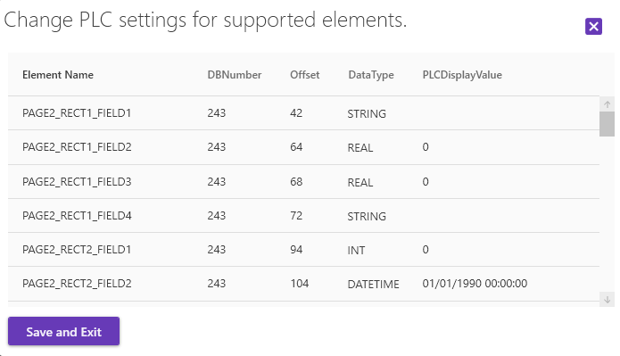

Figure 24 Change PLC Settings for element dialog

As you can see in this datagrid is the ‘ElementName’, ‘DBNumber’, ‘Offset’, ‘DataType’ and ‘PLCDisplayValue’.

**ElementName:** this is the name of the element that you are editing

**DBNumber:** The DBNumber that the element is pointing to when the trigger ‘CREATE_PDF’ is triggered.

**Offset:** The current offset.

**DataType:** The datatype of the current DB + Offset.

**PLCDisplayValue:** The value that will be displayed at runtime (Trigger ‘CREATE_PDF’ triggered). Do not change this. This will be removed in the future.

***Tip:*** When edited a cell press ‘Enter’ to move to the one below. Press ‘Tab’ to move to the one right.

# 5. Configuration

An configuration contains a PDF. This section will go into a little bit more detail than the ‘Starting up’ section.

## 5.2 Activating/Disabling a configuration

When you have successfully setup an configuration you can ‘Activate’ a configuration 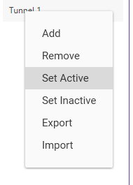

Figure 25 Activating a configuration

After you selected this the configuration will color green and this means it is actively checking the trigger on the ‘SecondsTimeOut’ that you have selected (Figure 8). Each time the trigger in the PLC is set to 1 a PDF will be created. All elements will retrieve their value and the PDF will be created in the ‘PDF Save Location’ (Figure 6 number 2).

To disable the configuration you can click ‘Set Inactive’ and it will be reset to Idle again. When you startup the application all configurations are set to ‘inactive’, until you enable them.

## 5.3 Importing/Exporting a configuration

There is also the ability to export and import an configuration

#### 5.3.1 Exporting a configuration

If you export the configuration you will be prompted with a dialog to select a folder. There the configuration will be saved to, with the configuration name as the filename.

#### 5.3.2 Importing a configuration

You can also import a configuration. You will be prompted with an dialog to select the file. After which the configuration will be imported. Do not forget to save the configuration in the ‘Configuration Editor’.

# 6 Tips and tricks

Sometimes there are more easy ways to use the application, any tips and tricks will be provided here.

## 6.2 Editing an element in place

When you have added an TextBlock for example (or other elements) and it needs quick adjustments you can just keep the ‘ElementName’ in place.

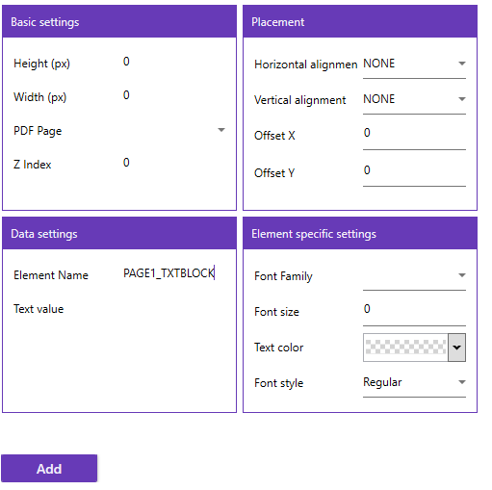

Figure 26 Trick editing element

When you click ‘Add’ the element with the ‘ElementName’ will be edited. This saves some time by not having to edit the element through the Elements List.

# 7. Known issues and bugs

Sadly, there will always be issues and bugs. Especially at the beginning. The procedure of notifying an issue is through Github.

<https://github.com/powerspex/ReportGenerator/issues>

through the ‘Issues’ tab on Github I can easily keep track of all issues/bugs and features that need to be added/fixed.

When you find a bug please report it there.

# 8. Documentation

The documentation is also found on Github. This file (and eventually the updated versions) are found on github.

<https://github.com/powerspex/ReportGenerator>

The latest documentation is found here.

# 9. Roadmap

**28-08-2020**  
As for now the roadmap is to provide a stable experience for the user with the current possibilities within the application. To fix the current existing bugs and provide a more smooth experience. The roadmap will be updated later on when new features or requests are made.